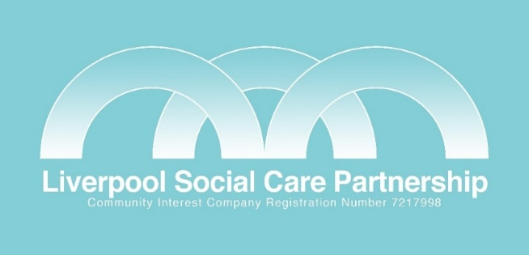

MEMBERSHIP APPLICATION & AGREEMENT

On behalf of (Organisation Name)

……………….………………………………………………………………

Professional Membership (£295 / Year) ☐

Premium Membership (£495 / Year) ☐

The organisation named above has applied to become a member of the Liverpool Social Care Partnership and agrees that it will pay the annual membership fee selected above (to be re-viewed annually) and comply with the above Terms of Reference.

Cheques should be made payable to Liverpool Social Care Partnership

Name (Print)………………………………………………………………………………………

Email……………………………………………

Tel………………………………………………... Date………………………………

Address………………………………………………………………………………………

…………………………………………………………………………………………………

Post Code…………………………….

Signature……………………………………………………………………………………

Please keep a copy of this page and return the original to the Managing Director at the Partnership.

Liverpool Social Care Partnership, C/O Lowlands, West Derby Community Association, 13 Hayman’s Green, West Derby, Liverpool L712 7JG

Additionally, payment can be made via BACS:
Account name is Liverpool Social Care Partnership
Bank – HSBC
Account No: 43957985
Sort Code:40.29.08

